Requirements:

- Java 9+

http://www.oracle.com/technetwork/java/javase/downloads/jdk9-downloads-3848520.html

- Adding Java to your path is recommended

- Admin requires a machine capable of openGL 3.0+

~~~~~Instructions~~~~~

All jars can be ran with through commandline as so -

java -jar JARNAME.jar "ARG0" "ARG1" ...

This tutorial assumes that you do not have java 9 on your path and you are running windows

1. Open terminal in the programs directory by holding shift and right clicking in an empty area of the folder and selecting Open command window here

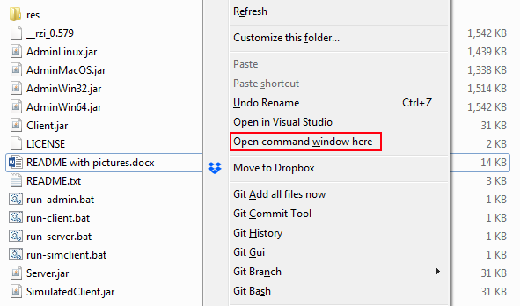

It should look something like this:

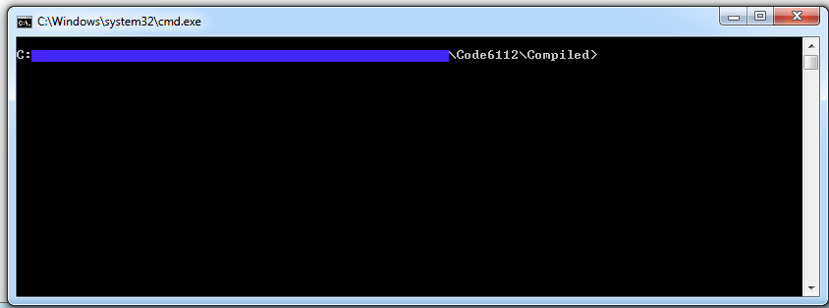

1. Locate your Java 9 installation and copy the path to its bin folder

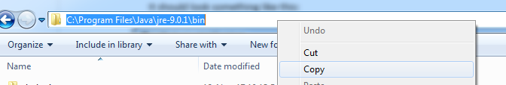

1. Back to the terminal, type a quotation mark and paste the Java 9 bin path

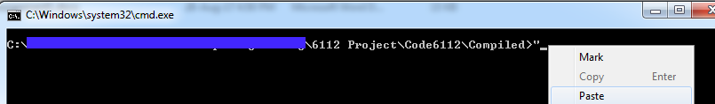

It should look something like this:

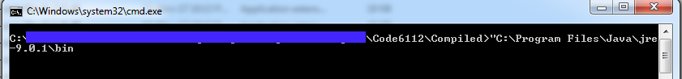

5. Lastly type \java.exe” –jar JARNAME.jar “PREFERED PORT” and hit enter

For running the server you’d get something like this:

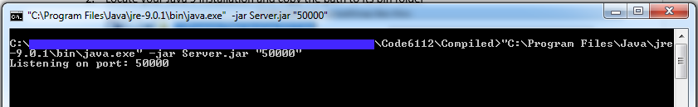

Where 50000 is the port you want to host on

For running the client you’d get something like this:

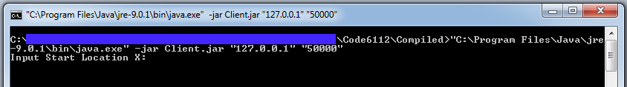

Where 127.0.0.1 is the server address and 50000 is the port the server is hosted on

For running the simulated client you’d get something like this:

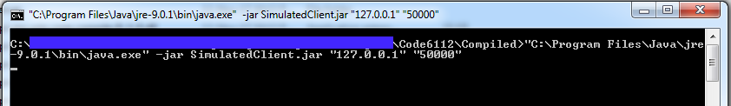

Where 127.0.0.1 is the server address and 50000 is the port the server is hosted on

For running the admin you’d get something like this:

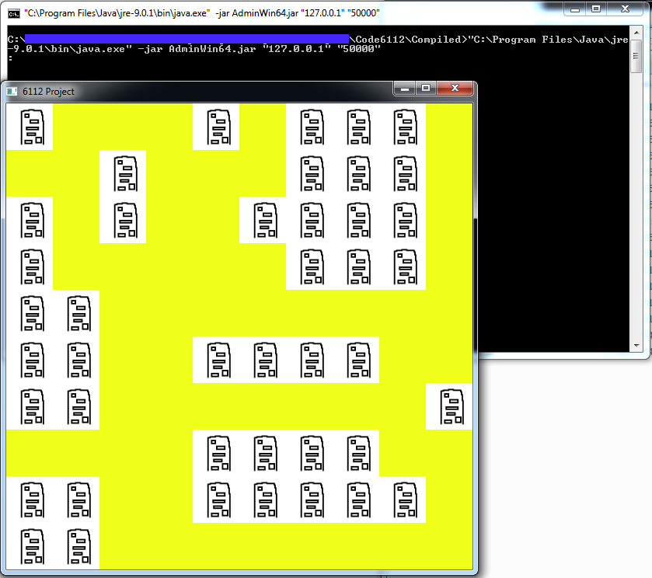

Where 127.0.0.1 is the server address and 50000 is the port the server is hosted on

NOTE: Each of these requires a new command window, make sure server is running first!